Visual organisers

Choose the name of each graph or diagram from the list below, and copy it next to each graph type. Then write the letter that corresponds to its function.

Bar chart, Carroll diagram, Cycle, Flow diagram (or flow chart), Grid, Key: binary, Line graph, Mind map (descriptive), Pie chart, Process diagram or cause/ effect diagram, Quadrants, Storyboard, T-chart, Table, Time line, Tree diagram, Venn diagrams.

a) To show the cause effect factors which lead to an outcome or a sequence of steps which leads to the manufacture of a product.
b) To show events in chronological order.
c) To divide information into two parts using a series of questions, each of which has only two possible answers.
d) To classify information according to two sets of different criteria.
e) To show different amounts of frequencies as parts of a circle.
f) To categorise information usually with columns and headings.
g) To show connections between two sets of concepts.
h) To show two sides of a topic such as for and against an argument; advantages and disadvantages; facts and opinions.
i) To show a trend or data using X and Y axes.
j) To show a series of events which happen again and again in the same order.
k) To show facts about specific people, places, objects or events.
l) To classify words and show their relationships often with examples.
m) To show frequency using rectangles which are the same width.
n) To show similarities and differences between two or among three objects, people, concepts, places etc., or to show a whole set of items and a sub-set of those items.
o) To show locations of places e.g. on maps.
p) To show the events in a story sometimes with speech and thought bubbles or short text.

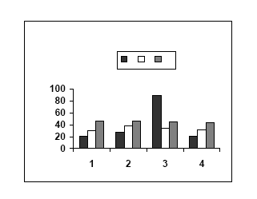  1 | 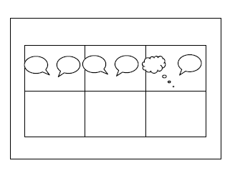  2 | 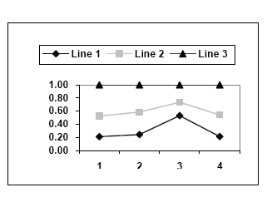  3
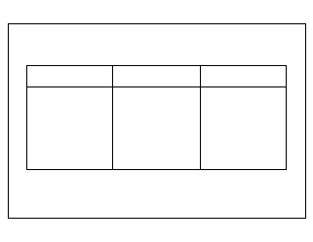  4 | 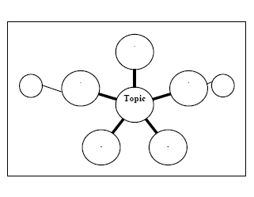  5 | 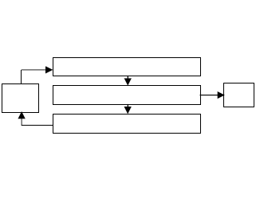  6
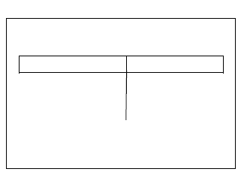  7 | 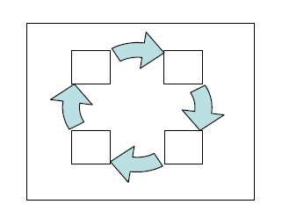  8 | 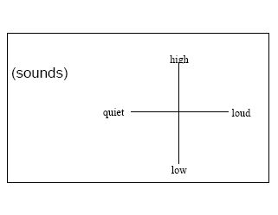  9
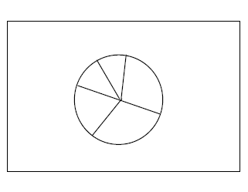  10 | 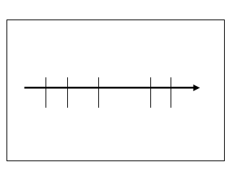  11 | 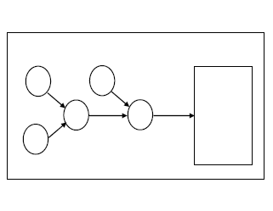  12
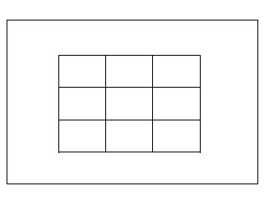  13 | 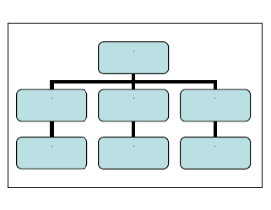  14 | 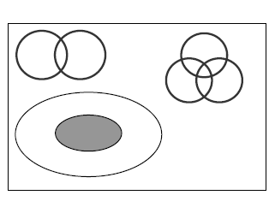  15
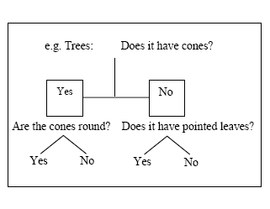  16 | 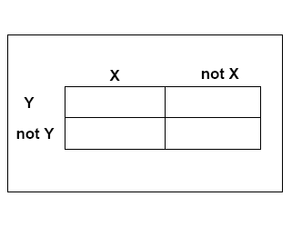  17

Answer key:

Visual organiser Purpose of organiser

1 Bar chart To show frequency using rectangles which are the same width.
17 Carroll diagram To classify information according to two sets of different criteria.
8 Cycle To show a series of events which happen again and again in the same order.
6 Flow diagram (or chart) To represent information to show the steps in a process or in making a decision.
13 Grid To show locations of places e.g. on maps.
16 Key: binary To divide information into two parts using a series of questions, each of which has only two possible answers.
3 Line graph To show a trend or data using X and Y axes.
5 Mind map (descriptive) To show facts about specific people, places, objects or events.
10 Pie chart To show different amounts of frequencies as parts of a circle.
12 Process diagram or
cause/ effect diagram To show the cause effect factors which lead to an outcome or a sequence of steps which leads to the manufacture of a product.
9 Quadrants To show connections between two sets of concepts.
2 Storyboard To show the events in a story sometimes with speech and thought bubbles or short text.
7 T-chart To show two sides of a topic such as for and against arguments; advantages and disadvantages; facts and opinions.
4 Table To categorise information usually with columns and headings.
11 Time line To show events in chronological order.
14 Tree diagram To classify words and show their relationships often with examples.
15 Venn diagrams To show similarities and differences between two or among three objects, people, concepts, places etc., or to show a whole set of items and a sub-set of those items.

Adapted from cambridge-clil-glossary.pdf
(University of Cambridge ESOL Examinations — Teaching Knowledge Test — CLIL — Glossary)

